Paper template for ML2P, Padova 2012
The author(s) first name, last name
Affiliation(s)
E-mail address(es)
ABSTRACT (11-point Times New Roman bold, centred)
Each article must include an abstract of 150 to 200 words in Times 11, single space. The heading Abstract should be centred, font Times 11 bold, with 12 pt space before and 6 after.

Keywords: There is space for up to five self-selected keywords.

INTRODUCTION
This is the layout specification and template definition for the papers of ML2P. The template is based on a modified version of the one used for ICPhS.
The abstract of 150-200 words may consist of more than one paragraph. References should be avoided unless impossible to do without.
The following rules apply to all submitted papers:
- they must be written in English
- the maximum is 5 pages for the Conference papers (except papers for Plenary Reports the maximum for which is 10 pages).
- they must be submitted in PDF file and doc file (no docx file!)
- the papers must be sent by email to ml2p.workshop@gmail.com.
This paper template in Word file can be found on the Conference website. If there are special questions or wishes regarding paper preparation and submission for ML2P, correspondence should be addressed to mariagrazia.busa@unipd.it .

PAGE LAYOUT AND STYLE
The page layout should conform to the following rules. The easiest way to meet these requirements is to use the supplied template and check details against this example file. If for some reason you cannot use the template, please follow these rules as carefully as possible, or contact mariagrazia.busa@unipd.it for further instructions.

Basic layout features
- Proceedings will be printed in A4 paper format. The layout is designed so that, when printed in US Letter format, files include all material but the margins are not symmetrical. Your submission must be in A4 format.
- Two columns are used except for the title part.
- Left margin is 250 mm. Right margin is 150 mm.
- Column width is 80 mm.
- Spacing between columns is 10 mm.
- Top margin 20 mm. Bottom margin 25 mm.
- Text height (without headers and footers) is a maximum of 235 mm.
- Headers and footers should be left empty (they will be added for printing and for the online version).
- Check indentations and spacings by comparing with this example file.

Headings
Section headings are centered in boldface with capitalized letters. Sub-headings start at the left margin in the column with the first letter capitalized and the rest of the heading in lower case. Sub-sub-headings appear like sub-headings, except that they are in italics and not boldface. See examples in this file. No more than 3 levels of headings should be used.

Text font
Times or Times New Roman font is used for the main text. Recommended font size is 12 points. Other font types may be used if needed for special purposes. When making the final PDF file, remember to include all fonts!

Figures
All figures should be centered on the column. Figure captions should precede each figure and have the format given in Fig. 1.
Figures should preferably be line drawings. If they contain gray shades or colors, it should be checked that they print well on a high-quality non-color laser printer.

Figure 1: The sonogram of the word “Alan”.
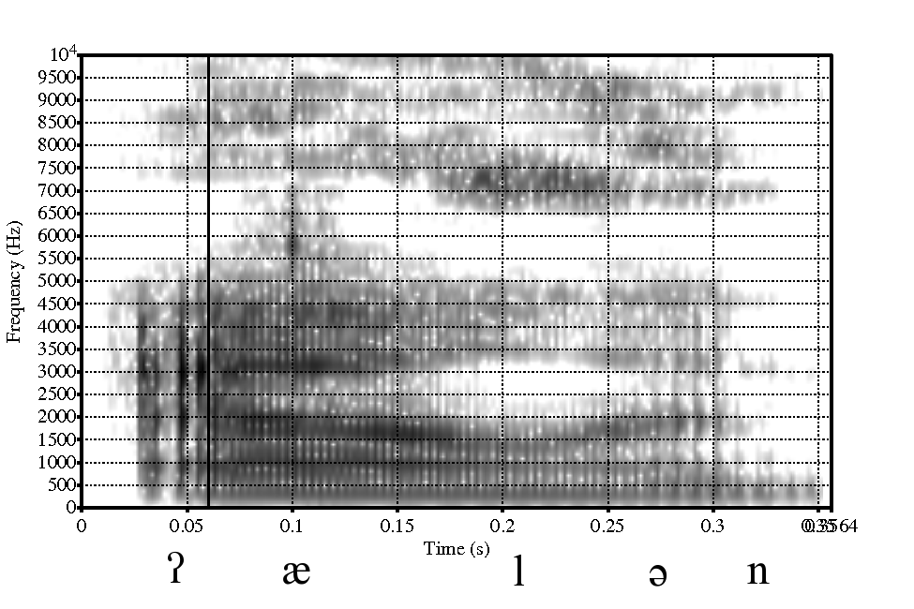

Tables
An example of a table is shown as Table 1. Somewhat different styles are allowed according to the type and purpose of the table. Color should not be used, but gray shading is allowed. There should be a margin of 6 points (pt) above and below the table.
The caption text may be above or below the table, but this should be consistent throughout the submission. Left and right indentation of the caption should be 0.5 cm.
Table 1: This is an example of a table showing Mean duration (ms) of plosives before stressed vowels.
plosive | Duration
b | 94
p | 128
k | 113
d | 93

Equations
Equations should be placed on separate lines and numbered. An example of an equation is given below:
Numbers of equations should be on the left margin of the text column.

Phonetic fonts
You can use phonetic symbols and special characters in your paper. To make sure that readers of your article can see the phonetic symbols in the PDF document, all special symbols must be embedded in the PDF.
It is recommended to use the following font to show phonetic symbols (links for free download can also be found at the Workshop website):
- SIL phonetic fonts [4]

Page numbering
Please do not add page numbers and please do not make any footers or headers. Page numbers will be added electronically to the document by the editors.

References
Please use just the reference number in square brackets. The only acceptable formulations with author names are like “according to Laver [4]”.
References are to be numbered in alphabetical order. Please double-check the final version of your paper with regard to the correct correspondence of references to their numbers.
Hyperlinks to web pages should be listed in the references section.

Footnotes and endnotes
Please do not use footnotes. If footnotes cannot be avoided they should appear as endnotes.

PDF DETAILS
PDF files submitted must comply with the following requirements:
- all special fonts and symbols must be embedded in the PDF file so that correct rendering of the PDF does not depend on the fonts installed on the viewer’s computer
- there must be no password protection on the PDF file, i.e. PDF files must not be protected by PDF security in any way, i.e. content extraction, document assembly, high-resolution printing etc. must not be forbidden
- PDF files should not contain any colors, hyperlinks, multimedia or 3D content, and no JavaScript or forms.

FORMAT OF REFERENCES
Monographs such as [2] consist of author(s) last name(s), initial of the first name(s), year of publication, the title in italics, location of the publication, publisher. Please use the punctuation signs for structuring as presented in [2].
The names of multiple authors are separated only by commas and they are always listed in the sequence last name, comma, initial(s) of the first name(s) (cf. the examples [1] and [6]).
Contributions to volumes, e.g. [7], follow the convention that the title of the volume is in italics, but not the title of the contribution. The book editors appear before the book title. The page numbers are at the end.
Journal articles should be handled in the same way as contributions to volumes except that the title of the journal is in italics and that the editors are not listed. Longer names of well-known journals can be abbreviated, e.g. [6].
Articles in conference proceedings such as [5] are referenced in the same way as journal articles. The word proceedings can be abbreviated and the location should be mentioned after the name of the conference. Here, abbreviations of well-known conferences are possible.
Internet resources should be handled as [3] and [4].

REFERENCES
- Byrd D., Saltzman E. 1998. Intragestural dynamics of multiple prosodic boundaries. J. Phonetics 26, 173–199.
- Odden, D. 2008. Introducing Phonology. Beijing: Cambridge University Press.
- Shih, C., Kochanski, G., Yoon, S-Y. The missing link between articulatory gestures and sentence planning. http://www.kochanski.org/ gkp/
- SIL phonetic fonts. http://scripts.sil.org/cms/scripts/page.php?site_id=nrsi&id=DoulosSIL_download#7de9e023
- Ladefoged, P. 2003. Phonetic fieldwork. Proc. 15th ICPhS Barcelona, 203-206.
- Maniwa, K., Jongman, A. 2009. Acoustic characteristics of clearly spoken English fricatives. J. Acoust. Soc. Am. 125, 3962-3973.
- Repp, B.H., Liberman, A.M. 1987. Phonetic Category boundaries are flexible. In: Harnad, S., Laver, J. (ed), Behavioral and Brain Science. NY: Cambridge University Press, 89-112.

